AI-Powered Handwritten Text Recognition System Using Convolutional Neural Networks

R. Sai Charan
Dept. of CSE
K L Deemed to be University
India
University ID: 2420030140
S. Sai Rishik
Dept. of CSE
K L Deemed to be University
India
University ID: 2420030121
M. Satya Charan Reddy
Dept. of CSE
K L Deemed to be University
India
University ID: 2420030166

Project Guide: Dr. N. Sunandha
Dept. of Computer Science and Engineering, K L Deemed to be University

Abstract
Recognizing handwritten text has become a crucial aspect of digitizing handwritten documents, notes, forms and educational materials. However, the variations in shapes of characters, size of characters, spacing between characters, writing style and angle makes it challenging to accurately recognize the text automatically. This paper discusses an AI based Handwritten Character Recognition System that converts handwritten images into editable text. An image can be uploaded and the image will be converted to grayscale, remove noise, resized, normalized and segmented. Then a convolutional neural network will be used to extract the unique features and classify letters and digits. Each prediction will have a confidence score associated with it. If the confidence is low, the system will give suggestions to correct it. The CNN was trained using the EMNIST data set and our own handwritten data set so that the model generalizes well for different writing styles. The results can be viewed on an interactive dashboard where the uploaded image can be viewed along with the predictions and confidence scores. The performance can be measured using accuracy, character error rate and word error rate. The system was created using Python with the libraries TensorFlow, Keras, OpenCV, NumPy, Pandas, Scikit-learn, Matplotlib and Streamlit. This system helps reduce the effort required to manually transcribe text by using image preprocessing, using deep learning to classify the text, analyzing the confidence scores and providing an interactive dashboard.
Keywords— Handwritten Text Recognition, Character Recognition, Convolutional Neural Network, Image Preprocessing, EMNIST, Deep Learning, Confidence Score

Introduction
Handwritten text is often used in notes, forms, exams, records and education. This information can often be difficult to modify, search, store and process. This makes it very useful to be able to convert handwriting to digital text automatically [1].
Handwritten Text Recognition (HTR) is a more challenging task than recognising printed text due to the variation in characters such as shapes, sizes, spacing, slope and alignment. Optical Character Recognition (OCR) systems tend to be better at recognising printed text, and can struggle with cursive, irregular or poor quality handwriting [1][2]. With the development of Deep Learning techniques, Convolutional Neural Networks (CNN) have been used to learn visual features from pixels. They have been successfully used in recognising digits since early LeNet models [3]. In addition, there are public data sets available, such as EMNIST, which expand upon the classic digit data set to include handwritten letters [4].
- This paper describes an AI system for recognising handwritten characters. An uploaded image goes through an automated pre-processing stage, then is recognised using a Convolutional Neural Network. The output will include editable and searchable text with a confidence score given for each prediction. The key contributions of this project are:
- End-to-end pipeline including uploading images, pre-processing, CNN recognition and outputting text.
- Confidence scoring system to identify uncertain predictions and provide suggestions for corrections.
- Training plan using EMNIST and a custom handwritten data set to increase the variety of writing styles.
- Evaluation method using Accuracy, Character Error Rate (CER) and Word Error Rate (WER).
- Interactive system created using Streamlit to display the input, predicted characters and confidence scores.
The remainder of the paper is structured as follows. Section II outlines the problem and aims. Section III provides background information and identifies the gap in research. Section IV details the proposed solution. Section V details the implementation. Section VI outlines the evaluation method. Section VII outlines the anticipated results. Section VIII concludes the paper.

Problem Statement and Objectives

Problem Statement
There are many difficulties when converting handwriting to digital format. Each character can vary drastically between authors due to differences in shape, size, spacing, style and alignment. Also with poor image quality there is an increase in noise. This makes handwriting hard to transcribe by hand which can be a slow process and prone to errors. Also with an OCR engine that has been trained on print characters, it will struggle with cursive and irregular handwriting that may have some degradation. We need a system that can accurately recognise the characters despite the variation in writing styles. It will need to be quantifiable so we can measure its accuracy and simple to use without any expert knowledge..
The aim is to make handwriting easier to convert to digital format. This will allow us to easily edit, store, search and process our information. Converting to digital format means we can make notes from our paper documents, save time by not having to re-type information, and search through our content..

Objectives
Four measurable objectives guide the project.
- Image processing: prepare handwritten images using resizing, normalization, and noise reduction.
- Text recognition: develop or integrate an AI model for handwritten character, word, or line recognition.
- Performance evaluation: evaluate CER, WER, and recognition accuracy on a representative test set.
- Digital text generation: generate clear, editable, and searchable digital text.
Meeting these objectives is expected to yield a functional prototype that converts handwriting to text automatically, reports measurable accuracy, reduces transcription effort, and presents user-friendly output.

Literature Survey
Many surveys exist about HTR. Some categorise systems based on the techniques used, the data, the year they were published, and their recognition level [1]. Others group methods according to the recognition granularity and show the benefits of pre-training transformer models using synthetic data [2]. A systematic survey was made by de Sousa Neto et al., focusing on data augmentation, an important technique for offline HTR systems [5]. There are four groups of approaches found in Table I, where we focus on the trade-off of each in order to design our system.
- Comparison of Handwriting Recognition Approaches
Approach and technique | Advantages | Limitations
Traditional OCR: image processing with handcrafted features | Simple and lightweight | Mainly suited to printed text; weak under handwriting variation
CNN-based recognition: visual feature extraction | Effective for character and image recognition | Limited for long sequences; needs prepared input
CNN + LSTM + CTC: CNN extraction, LSTM sequence model, CTC alignment | Handles variable-length sequences; suited to words and lines | Higher computation; complex training
Transformer-based HTR: vision and text Transformer architecture | Captures contextual dependencies | Often needs substantial data and computation

Traditional Optical Character Recognition
Traditional OCR methods make use of image processing along with manually designed features. These methods are simple and easy to implement however they are primarily designed for printed characters and can be affected by variations in a users handwriting.

Convolutional Neural Network Recognition
CNN based methods can automatically extract visual features from images [3]. These have been shown to be effective at recognising characters and images however they do not work well with long sequences of text and require pre-segmentation and pre-processing of the input..

Recurrent Sequence Models
CNNs can be combined with LSTM sequence models and CTC alignment algorithm [6][7]. This allows recognition of variable-length sequences. Whilst this provides flexibility for words and lines it increases complexity and computation.
.

Transformer-Based Recognition
TrOCR is an example of a recogniser using Transformers. These use image and text Transformers to encode and decode the image. This requires large pre-training [8]. Transformers are good at capturing context but usually require large amounts of data.

Research Gap
Upon review of the above methods there is a gap in practicality. This includes:.
- High variability in handwriting.
- Difficult to recognise cursive and irregular text.
- Unreliable when images are of poor quality/noisy.
- Computationally intensive with advanced models.
- User-friendly processes required for practical implementation.
Therefore in order for the HTR system to be practical a balance must be made between accuracy, reliability and efficiency. This will be achieved with the following design.

Proposed System
The proposed system is designed to provide an end-to-end solution to HTR. The process includes pre-processing, AI-based recognition, and analysis, providing an editable digital output. As shown in Fig. 1, the handwritten image goes through pre-processing, to extract features from the image. It then has a CNN applied to classify the image, and confidence analysis to provide a result to the user. The pre-processing, AI-based recognition, analysis and editable digital result each solve a problem found within section III. The AI-based recognition provides more robustness to handwriting variations, the pre-processing is automated to avoid any manual or inconsistent processing of the image, analysis using CER, WER and accuracy provides quantifiable results, and the digital editable output can be used practically.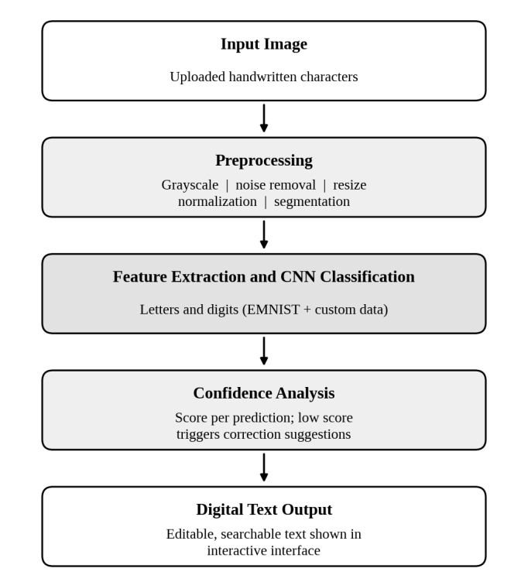
- Architecture of the proposed handwritten text recognition pipeline.

Image Acquisition and Preprocessing
The user uploads an image of handwritten characters. The image is converted to grayscale to discard color information and reduce the amount of data to process. Noise is removed with smoothing filters from the OpenCV library [9]. The image is then resized to the fixed input dimensions expected by the network, and pixel intensities are normalized to a common range. When an image contains more than one character, segmentation separates it into individual character regions that are passed to the classifier one at a time.

Feature Extraction and Convolutional Neural Network Classification
The classifier is a CNN. Stacked convolutional layers with nonlinear activation and pooling learn stroke-level and shape-level patterns such as edges, curves, loops, and junctions, and fully connected layers combine these features into a decision. The output layer applies the softmax function, which converts the class scores into probabilities:
pi = exp(zi) / ∑j exp(zj) (1)
where zi is the score of class i and the sum runs over all classes, which cover the digits and the letters. The class with the highest probability is taken as the recognized character.

Confidence Scoring and Correction Suggestions
The he highest softmax probability is reported as the confidence score of the prediction. If the score falls below a threshold tuned on validation data, the prediction is marked as uncertain and the interface displays correction suggestions: the next most probable classes and, for word-level output, dictionary-based candidate corrections. This lets the user verify doubtful characters quickly instead of proofreading the entire output.

Datasets and Augmentation
The The network is trained on EMNIST [4], which provides handwritten digits and letters in a standardized image format, together with a custom handwriting dataset that captures additional writing styles. The data are divided into training, validation, and test subsets. Augmentation such as small rotations, shifts, and scaling simulates natural writing variation and is widely used to improve generalization when handwriting data are limited [5].

Extension to Word-Level and Line-Level Recognition
Because the objectives include word and line recognition, the character classifier is designed as the base of a larger system. Segmenting a line into characters and concatenating the predictions yields word-level and sentence-level text. For cursive or touching characters, where segmentation is unreliable, the recognizer can be extended with LSTM and CTC layers [6], [7], which do not require explicit character segmentation.

Interactive Interface
Results are presented through an interactive web interface. The user can view the uploaded image, the predicted characters, the confidence level of each prediction, and the correction suggestions, and can then edit the recognized text.

Implementation
The system is developed in Python. Table II lists the libraries used and their roles in the pipeline.
- Technology Stack
Tool | Role in the system
Python | Core programming language
TensorFlow and Keras | Building, training, and running the CNN
OpenCV | Grayscale conversion, noise removal, resizing, and segmentation
NumPy and Pandas | Array handling, normalization, and dataset management
Scikit-learn | Data splitting and evaluation metrics
Matplotlib | Training curves and confusion-matrix plots
Streamlit | Interactive web interface

he CNN is built and trained with TensorFlow and Keras. Training minimizes the categorical cross-entropy loss with the Adam optimizer [10]. The design includes dropout [11] and batch normalization [12] to limit overfitting and stabilize training, and hyperparameters such as the learning rate, batch size, and number of epochs are tuned on the validation subset. Pandas and NumPy manage the dataset and its labels, while Scikit-learn provides the data splits and evaluation metrics.
The Streamlit application wraps the trained model in a simple upload-and-view workflow, so that no programming knowledge is needed to use the system

Evaluation Methodology
Performance is measured on a representative test set that contains held-out EMNIST samples and custom handwriting samples that were not used in training. Table III lists the metrics.
- Evaluation Metrics
Metric | What it measures
Recognition accuracy | Share of characters classified correctly on the test set
Character error rate | Substitutions, deletions, and insertions per reference character
Word error rate | The same edit-based error computed at word level
Confusion matrix | Class-wise errors between visually similar characters
Precision, recall, and F1-score | Per-class reliability and coverage
Confidence score | Agreement between confidence and correctness, used to set the low-confidence threshold

Recognition accuracy is the proportion of correctly recognized characters:
Accuracy = N_{correct} / N_{total} (2)
CER measures the edit distance between the recognized text and the reference text, normalized by the reference length:
CER = (S + D + I) / N (3)
where S, D, and I are the numbers of substitutions, deletions, and insertions, and N is the number of characters in the reference. WER is computed in the same way over words. The confusion matrix highlights systematic errors between similar characters, and the confidence scores are compared with correctness to choose the threshold used for correction suggestions.

Expected Outcomes and Discussion
This report presents the problem, the survey, and the proposed design. Quantitative results are not included here and will be reported once the evaluation described in Section VI is complete. The design is expected to deliver a functional prototype, automatic conversion of handwritten images into digital text, measurable accuracy through accuracy, CER, and WER, reduced transcription effort, and user-friendly output.
Several factors are expected to influence performance. Visually similar characters, such as the letter O and the digit 0, or the letters I and l and the digit 1, are likely sources of confusion; the confidence score and the correction suggestions are intended to bring exactly these cases to the user’s attention. Noisy or low-resolution images may reduce reliability, which is why preprocessing is a distinct stage of the pipeline. Finally, character-level classification depends on correct segmentation, so cursive and heavily connected handwriting remains the hardest case and motivates the sequence-model extension described in Section IV.

Output
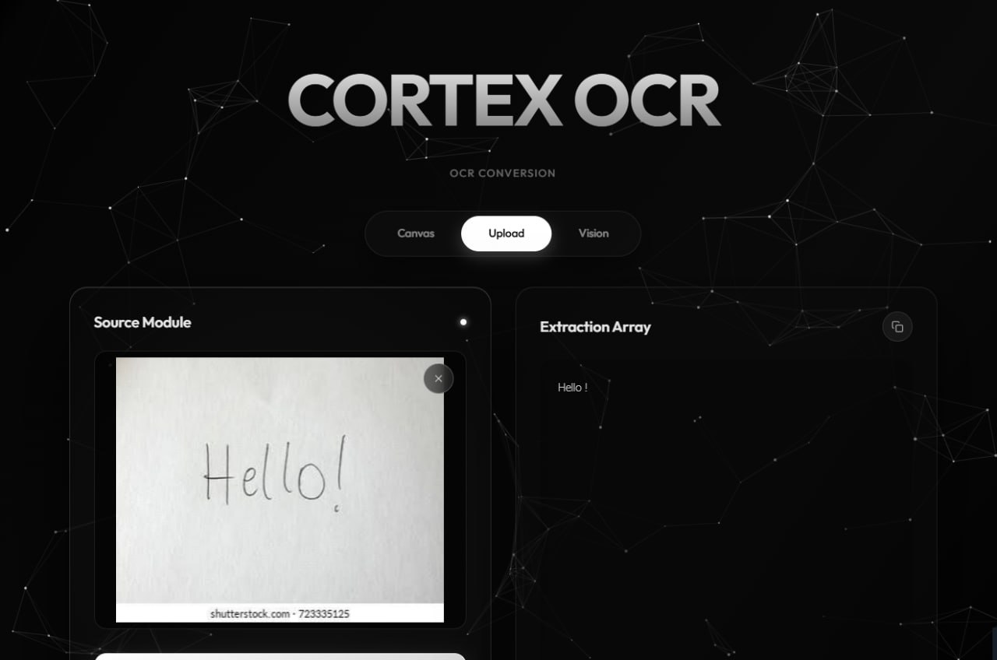

Conclusion and Future Work
This paper presented an AI-powered handwritten text recognition system that converts handwritten characters into digital text. By combining automated image preprocessing, CNN-based classification, confidence analysis with correction suggestions, and an interactive interface, the system aims to reduce manual transcription and provide a fast, intelligent, and reliable route from handwriting to editable text.
Future work includes completing training and reporting accuracy, CER, and WER on the test set, enlarging the custom dataset, extending recognition to words and sentences with CNN, LSTM, and CTC models, and exploring Transformer-based recognizers when data and computing resources allow.

Acknowledgment
The authors thank Dr. N. Sunandha, Project Guide, and the Department of Computer Science and Engineering, K L Deemed to be University, for their guidance and support during the Data Science (24AD3107) project.

References
- W. AlKendi, F. Gechter, L. Heyberger, and C. Guyeux, “Advancements and challenges in handwritten text recognition: A comprehensive survey,” J. Imaging, vol. 10, no. 1, Art. no. 18, Jan. 2024, doi: 10.3390/jimaging10010018.
- C. Garrido-Muñoz, A. Rios-Vila, and J. Calvo-Zaragoza, “Handwritten text recognition: A survey,” 2025, arXiv:2502.08417.
- Y. LeCun, L. Bottou, Y. Bengio, and P. Haffner, “Gradient-based learning applied to document recognition,” Proc. IEEE, vol. 86, no. 11, pp. 2278–2324, Nov. 1998.
- G. Cohen, S. Afshar, J. Tapson, and A. van Schaik, “EMNIST: Extending MNIST to handwritten letters,” in Proc. Int. Joint Conf. Neural Netw. (IJCNN), 2017, pp. 2921–2926.
- A. F. de Sousa Neto, B. L. D. Bezerra, G. C. D. de Moura, and A. H. Toselli, “Data augmentation for offline handwritten text recognition: A systematic literature review,” SN Comput. Sci., vol. 5, no. 2, Art. no. 258, 2024, doi: 10.1007/s42979-023-02583-6.
- B. Shi, X. Bai, and C. Yao, “An end-to-end trainable neural network for image-based sequence recognition and its application to scene text recognition,” IEEE Trans. Pattern Anal. Mach. Intell., vol. 39, no. 11, pp. 2298–2304, Nov. 2017.
- A. Graves, S. Fernández, F. Gomez, and J. Schmidhuber, “Connectionist temporal classification: Labelling unsegmented sequence data with recurrent neural networks,” in Proc. 23rd Int. Conf. Mach. Learn. (ICML), 2006, pp. 369–376.
- M. Li et al., “TrOCR: Transformer-based optical character recognition with pre-trained models,” in Proc. AAAI Conf. Artif. Intell., vol. 37, no. 11, 2023, pp. 13094–13102.
- G. Bradski, “The OpenCV library,” Dr. Dobb’s J. Softw. Tools, 2000.
- D. P. Kingma and J. Ba, “Adam: A method for stochastic optimization,” 2014, arXiv:1412.6980.
- N. Srivastava, G. Hinton, A. Krizhevsky, I. Sutskever, and R. Salakhutdinov, “Dropout: A simple way to prevent neural networks from overfitting,” J. Mach. Learn. Res., vol. 15, no. 56, pp. 1929–1958, 2014.
- S. Ioffe and C. Szegedy, “Batch normalization: Accelerating deep network training by reducing internal covariate shift,” in Proc. 32nd Int. Conf. Mach. Learn. (ICML), 2015, pp. 448–456.

